Relationship between the Property Crime and Percentage of the population with a bachelor’s degree: Negative

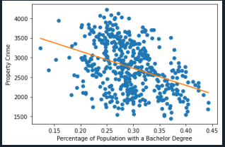

Relationship between the Property Crime and Per Capita Personal Income: Negative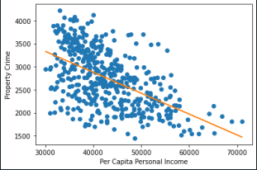

Relationship between the Property Crime and Unemployment rate: Positive

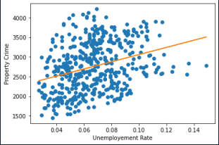

Relationship between the Property Crime and Police Presence per 100,000 population: No relationship

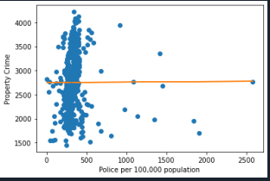

Relationship between the Property Crime and Death Penalty: No relationship

